**DELETE CODE**

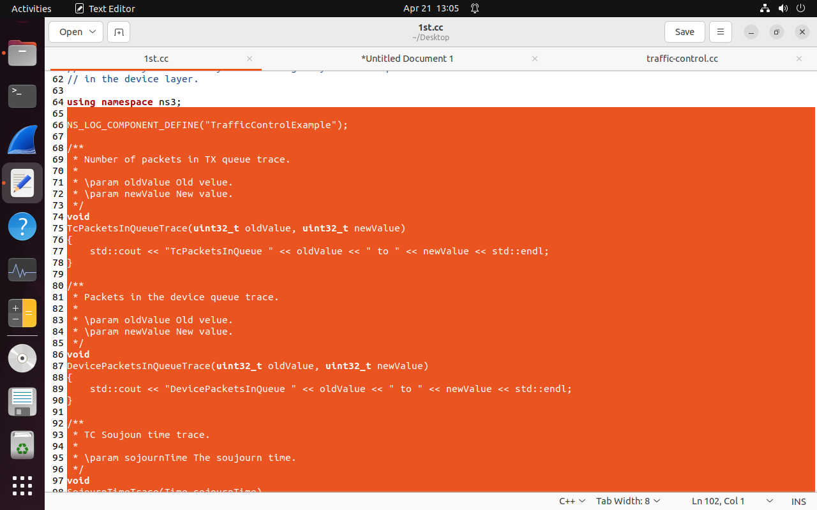

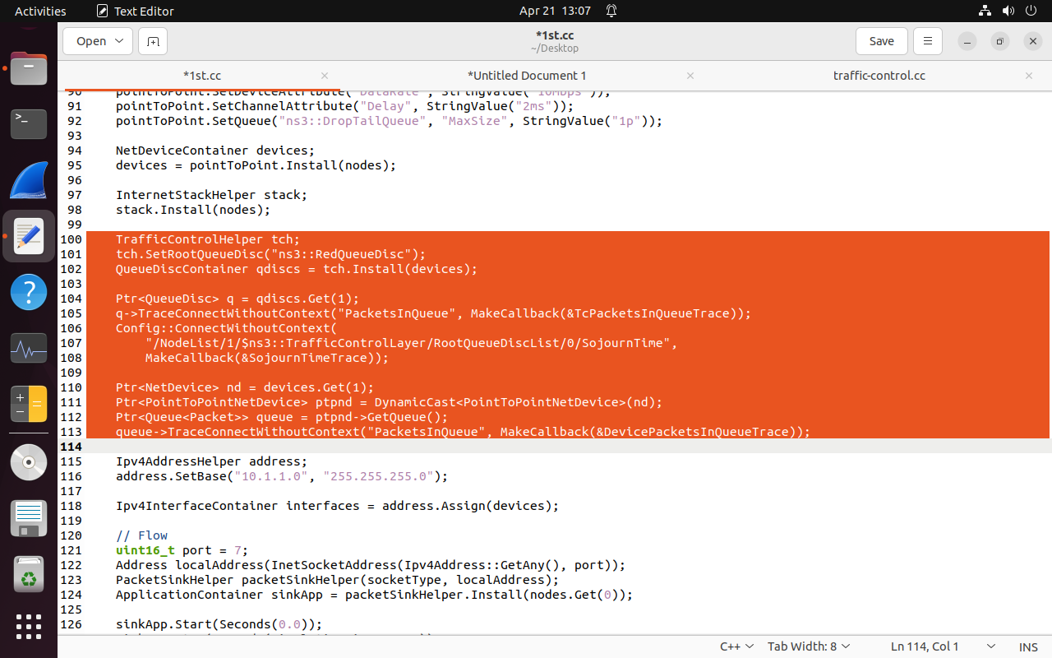

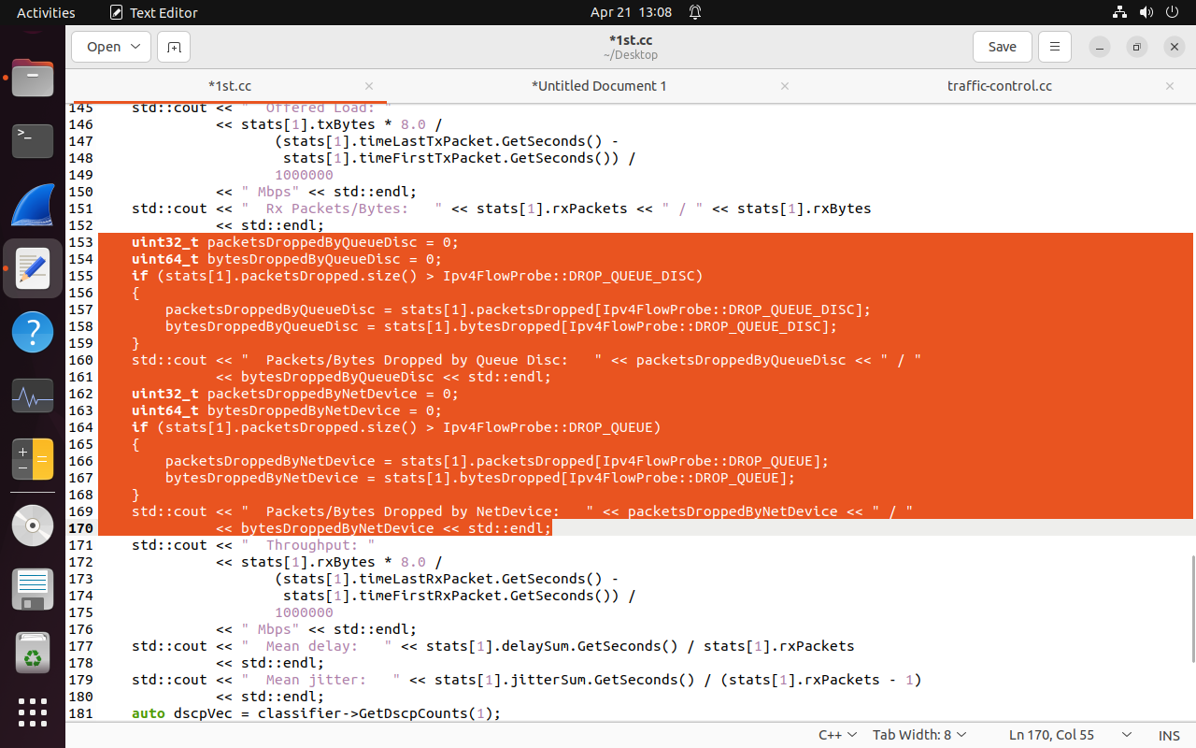

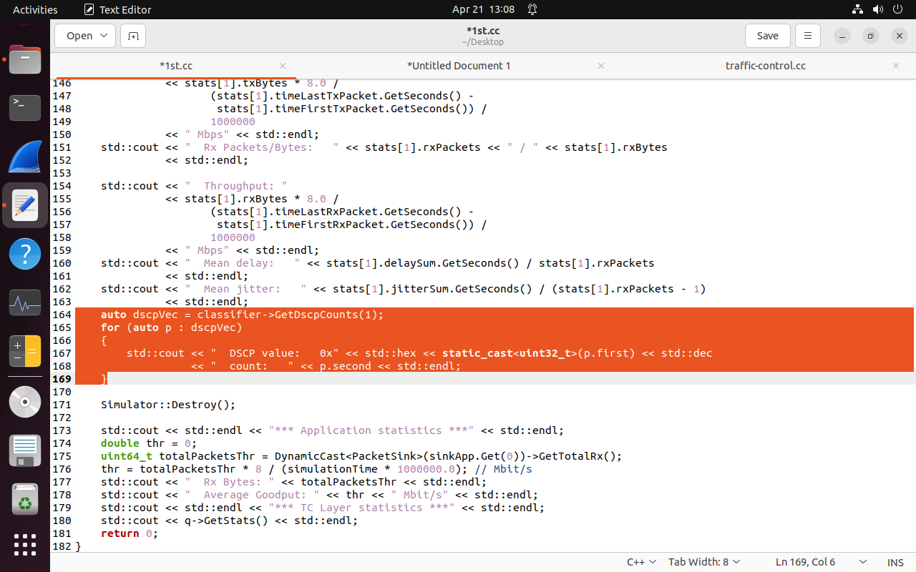

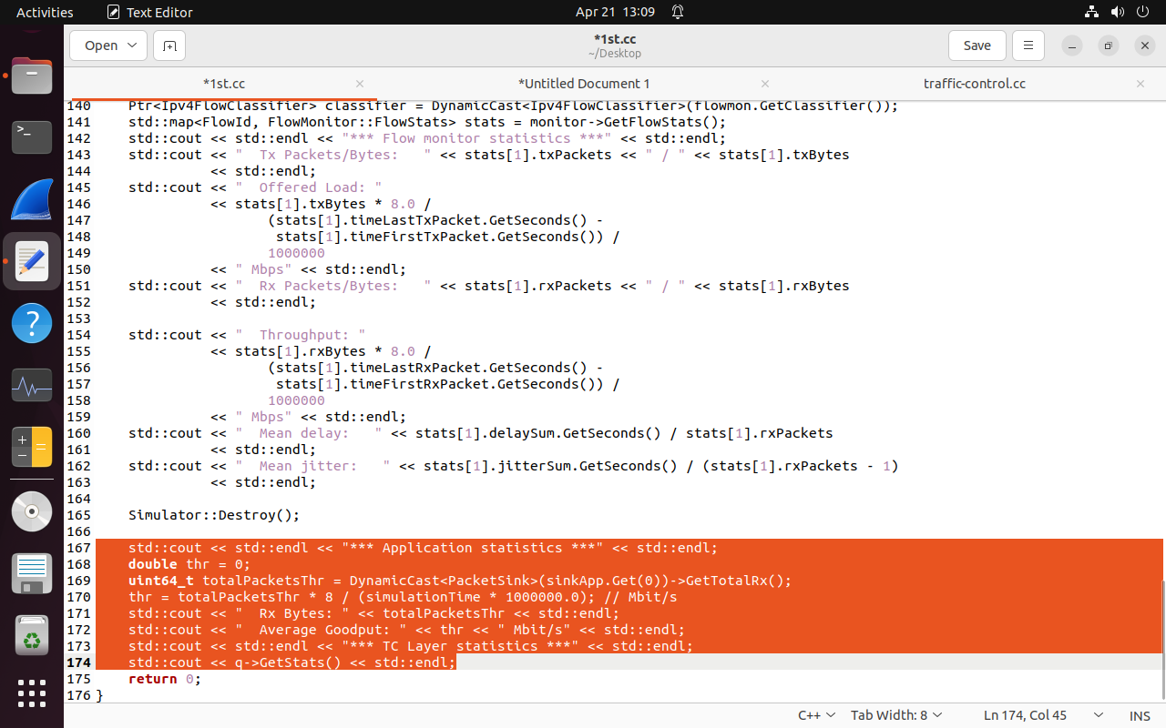

**CHANGES IN CODE**

std::string transportProt = "Udp"; // Changed transport protocol to UDP

nodes.Create(4); // Modified network topology to include 4 nodes

NetDeviceContainer devices01;

devices01 = pointToPoint.Install(nodes.Get(0), nodes.Get(1));

NetDeviceContainer devices12;

devices12 = pointToPoint.Install(nodes.Get(1), nodes.Get(2));

NetDeviceContainer devices23;

devices23 = pointToPoint.Install(nodes.Get(2), nodes.Get(3));

//Ipv4AddressHelper address;

//address.SetBase("10.1.1.0", "255.255.255.0");

Ipv4InterfaceContainer interfaces01 = address.Assign(devices01);

address.SetBase("10.1.2.0", "255.255.255.0");

Ipv4InterfaceContainer interfaces12 = address.Assign(devices12);

address.SetBase("10.1.3.0", "255.255.255.0");

Ipv4InterfaceContainer interfaces23 = address.Assign(devices23);

Ipv4GlobalRoutingHelper::PopulateRoutingTables(); //add these line after the following

//Flow

ApplicationContainer sinkApp = packetSinkHelper.Install(nodes.Get(3)); // change it to .Get(3)

InetSocketAddress rmt(interfaces23.GetAddress(1), port); // Set UDP destination address

apps.Add(onoff.Install(nodes.Get(0))); // Configure UDP traffic